**CLASSIFICATION OF IMAGES BASED ON MEMORABLE SCORE**

Harsha Priya G

2019207029

M.E CSE

**Guided By**

Dr V. Mary Anita Rajam

Professor

Department of Computer Science and Engineering

Anna University

**Date :** 28-08-2020 **Signature**

**PROBLEM STATEMENT**

To predict which region of the images are memorable using Computer vision techniques and deep learning architectures of Visual Memory Schema. To analyse the image memorability selections and the results using the transfer learning at the output of the various network layers. To serve the purpose of enhancing the human understandability, diagnose memory problems, for effective retrieval of image search, Computer Graphics and summarization of Big data images and videos etc...

**PHASE 1 PROBLEM STATEMENT**

To use the Computer vision techniques to collect the datasets for Visual Memory Schema Implementation. They then extract the features for image processing and formulate the Hit Rate and False Alarm ratio. Then they analyse the visualisations and get the memorability score of Images ranging from least memorable, moderately memorable and highly memorable.

**PHASE 2 PROBLEM STATEMENT**

To use the deep learning algorithms to extract the Places CNN dataset. To process the images without distortion and disturbances. To use the efficient MemNet algorithm to get the scores. To convert the image to heat map and they then plot which of the images are memorable and not memorable and predict the category of image.

**BRIEF SUMMARY OF RELATED WORK**

E. Tulving in his work, “Organization of memory” best describes how memories play an important role in learning. The work emphasises more on how the memories form the essential component to define ourselves [1]

T. F. Brady et’al on their work “A review of visual memory capacity: Beyond individual items and toward structured representations” illustrates the human memory capacity for visual information absorption and retrieval of images from the memory.[2]

L. Standing et’al on their work “Verbal-pictorial transformations in recognition memory” performed two experiments during which subjects learned either footage or descriptions of footage of images and they’re then tested for recognition with either pictures or descriptions, altogether four mixtures. Recognition was best within the Picture-Picture condition, intermediate within the Picture-Word and Word-Word conditions which failed to take issue significantly, and worst within the Word-Picture condition. the additional variety of errors accessorial by dynamical to a metamorphosis condition (Picture-Word or Word-Picture) from the corresponding non-transformation condition (Picture-Picture or Word-Word respectively), was constant in either case. A model for recognition memory is projected that postulates that each pictorial stimuli and descriptive verbal stimuli are encoded in a very pictorial (or functionally equivalent) kind to that later transformations could also be applied by the experimental task. This model uses 2 parameters: a coffee background level related to pictorial secret writing and storage, and the next background level related to creating a verbal-pictorial transformation (or vice versa). The model is supported by a re-analysis of the information of Jenkins, Neale, and Deno (1967) and by the information of the 2 gift experiments. a further question, the chance of twin process of verbal and pictorial stimuli, was examined by using each footage and descriptions at the same time within the learning session and/or the take a look at the session. proof suggesting stereophonic operation was obtained in 3 out of 5 experimental conditions.[3]

P. Isola et’al on the work “Understanding the intrinsic memorability of images,” in conference on Neural information processing Systems, explained how the images exhibit the intrinsic property. Artists, advertisers, and photographers square measure habitually given with the task of making a picture can bear in mind ,whereas it's going to seem to be image memorability is only subjective, recent work shows that it's not associate degree paradoxical phenomenon: variation in memorability of pictures is consistent across subjects, suggesting that some pictures square measure in and of itself a lot of unforgettable than others, freelance of a subjects' contexts and biases. During this paper work, they tend to use the publically offered memorability dataset of Isola et al., and increased the article and scene annotations with explainable spatial, content, and they tend to used a feature-selection theme with fascinating explaining-away properties to work out a compact set of attributes that characterizes the memorability of any person image. They discover that pictures of fogbound areas containing folks with visible faces square measure unforgettable, whereas pictures of vistas and peaceful scenes don't seem to be. Contrary to fashionable belief, uncommon or esthetical pleasing scenes don't tend to be extremely unforgettable. This work represents one in all the primary tries at understanding intrinsic image memorability, and opens a replacement domain of investigation at the interface between human knowledge and pc vision. [4]

Z. Bylinskii et’al work on “Intrinsic and extrinsic effects on image memorability” ,explains how the intrinsic and extrinsic effects on image memorability. Previous studies have known that pictures carry the attribute of memorability, a prophetical worth of whether or not a unique image are going to be later remembered or forgotten. Here the work has a tendency to investigate the interaction between intrinsic and foreign factors that have an effect on image memorability. Firstly, they discovered that intrinsic variations in memorability exist at a finer-grained scale than antecedent documented. Secondly, they checked 2 foreign factors: image context and observer behaviour. Building on previous findings that pictures that area unit distinct with regard to their context area unit higher remembered, they proposed associate degree information-theoretic model of .Their model mechanically predicted amendments in the context change of the memorability of natural pictures. Additionally to context, they studied a second foreign factor: wherever associate degree observer appearance whereas memorizing a picture. It seems that eye movements give extra info which will predict whether or not or not a picture are going to be remembered, on a trial-by-trial basis. [5]

A. Oliva et’al work on “A holistic representation of the spatial envelope”, explains how to model the shape of the scene using a holistic representation of the spatial envelope. In this paper, their work tend to propose a process model of the popularity of universe scenes that bypasses the segmentation and also the process of individual objects or regions. The procedure relies on a awfully low dimensional illustration of the scene, that their work tend to term the abstraction Envelope their work tend to propose a collection of sensory activity dimensions(naturalness, openness, roughness, expansion, ruggedness) that represent the dominant abstraction structure of a scene. Then, their work tend to show that these dimensions is also dependably calculable exploitation spectral and coarsely localized info. The model generates a multidimensional area during which scenes sharing membership in linguistics classes (e.g.,streets, highways, coasts) ar projected closed along. The performance of the abstraction envelope model shows that specific info regarding object form or identity isn't a demand for scene categorization which modelling a holistic illustration of the scene informs regarding its probable linguistics class. [6]

**HIGH LEVEL BLOCK DIAGRAM PHASE 1:**

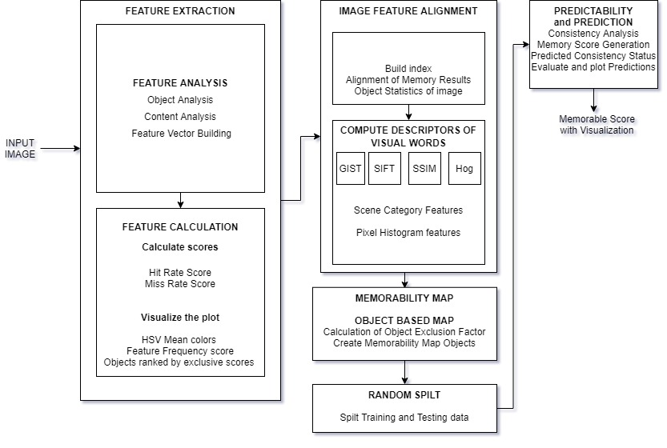

**PHASE 1 DETAILED BLOCK DIAGRAM**

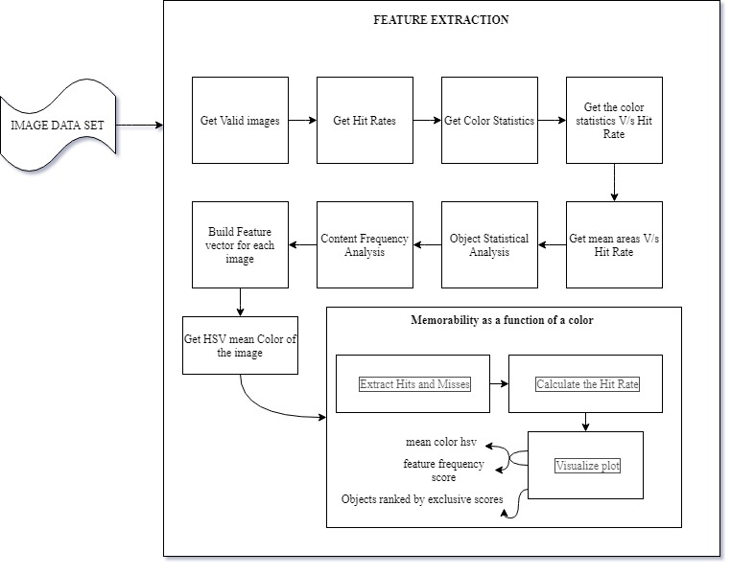

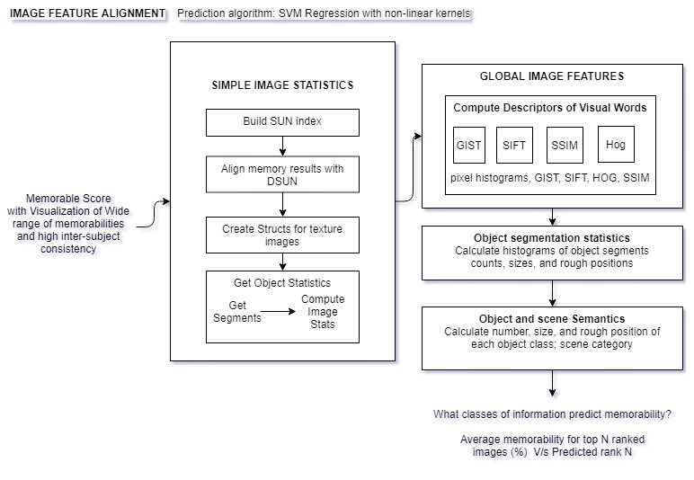

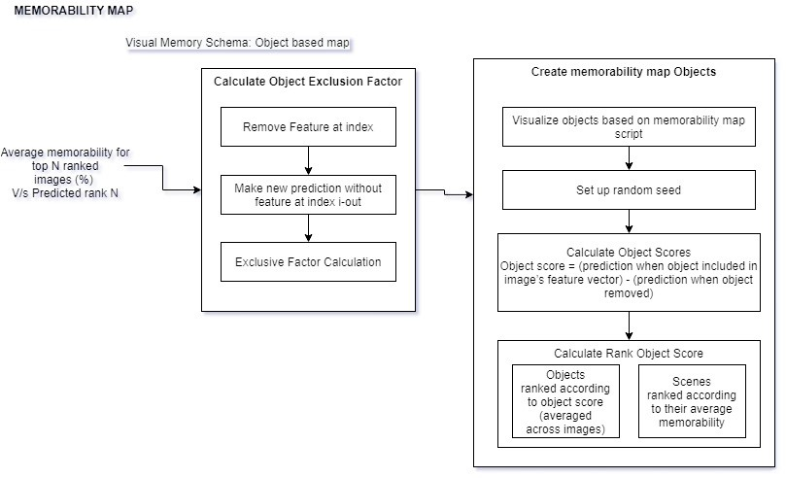

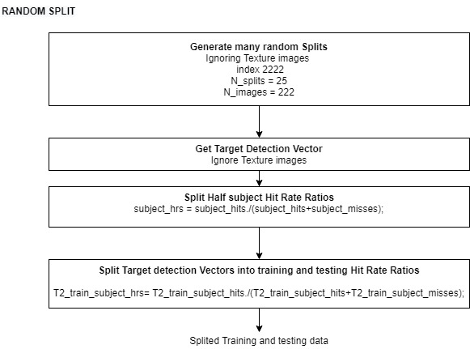

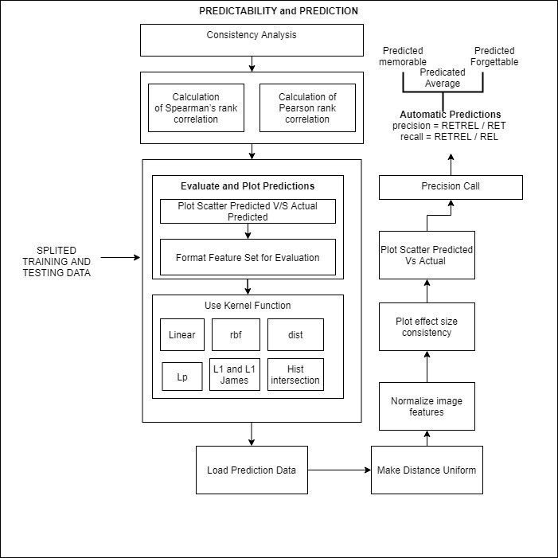

Fig 1 To visualise the memorability of the image

**ALGORITHM FOR DISSERTATION 1**

procedure Memorable_Score(X){

y=f(X)

x1 = input_data(image)

x2 = get_features(X)

false_alarm_count = 0, score = 0;

while (x1 != '\0') {

​if (x1 == retrievable) {

​​hit_rate = Number of Images chosen correctly as remembered by observers(x1) ÷ Total number of their occurrences as a repeat image(n)

​​score++;

}

​else if (x1 == retrievable and false_retrival){

​​hit_rate = Number of Images chosen correctly as remembered by observers ÷ Total number of their occurrences as a repeat image

​​false_alarm = false_alarm_count + 1;

​​score = score + false_alarm;

}

​else

​​false_alarm++;

}

return Memorable_Score[0,1];

}

**FINAL DELIVERABLES OF DISSERTATION 1**

Computing features of new images, predicting their memorability, and replicating the results.

**DATASET DESCRIPTION OF DISSERTATION 1**

The IMAGE datasets:

Database: 2222 photographs from SUN database: Includes target and filler images. It includes Pre computed features and annotations. Memorability measurements are taken from "Memory Game“.

**PERFORMANCE METRICS FOR DISSERTATION 1**

Memorability = probability of correctly detecting a repeat after a single view of an image in a long stream.

Object score = (prediction when object included in image’s feature vector) - (prediction when object removed)

Hit Rate = Number of Images chosen correctly as remembered by observers ÷ Total number of their occurrences as a repeat image.

False Alarm Rate (FAR) = False Hits of an Image ÷ Total number of its occurrences as a second-stage-filler (i.e. non-repeat) image.

Pearson linear correlation coefficient c denoted as ρ2D 

Mutual information (MI) criterion, denoted as IA,B



* A confidence scale allows us to produce ROC curves that provided us with a sensitivity measure of the experiment.

**REFERENCES**

[1] E. Tulving, Organization of memory. Academic Press, New York, 1972, ch. Episodic and semantic memory, pp. 381–403.

[2] T. F. Brady, T. Konkle, and G. A. Alvarez, “A review of visual memory capacity: Beyond individual items and toward structured representations,” Journal of Vision, vol. 11, no. 5, pp. 1–34, 2011.

[3] L. Standing and P. Smith, “Verbal-pictorial transformations in recognition memory.”Canadian Journal of Psychology, vol. 29, no. 4, pp.316–326, 1975.

[4] P. Isola, D. Parikh, A. Torralba, and A. Oliva, “Understanding the intrinsic memorability of images,” in conference on Neural information processing Systems (NIPS), 2011.

[5] Z. Bylinskii, P. Isola, C. Bainbridge, A. Torralba, and A. Oliva, “Intrinsic and extrinsic effects on image memorability,” Vision Research, vol. 116, pp. 16–178, 2015.

[6] A. Oliva and A. Torralba, “Modeling the shape of the scene: A holistic representation of the spatial envelope,” Int. J. Computer. Vision, vol. 42, no. 3, pp. 145–175, May 2001